Experiment 17: Change Hardware Compatibility of a VM and Run Simple UNIX Commands

Aim:
To change the hardware compatibility of an existing virtual machine and execute simple UNIX commands.

Procedure:
Step 1: Open VMware Workstation and select the existing virtual machine.
Step 2: Click VM → Manage → Change Hardware Compatibility.
Step 3: Select the required hardware compatibility version and click Next.
Step 4: Click Finish to apply the changes and power on the virtual machine.
Step 5: Open the terminal and execute simple UNIX commands such as:
- pwd
- ls
- date
- whoami
- uname -a

STEP1:
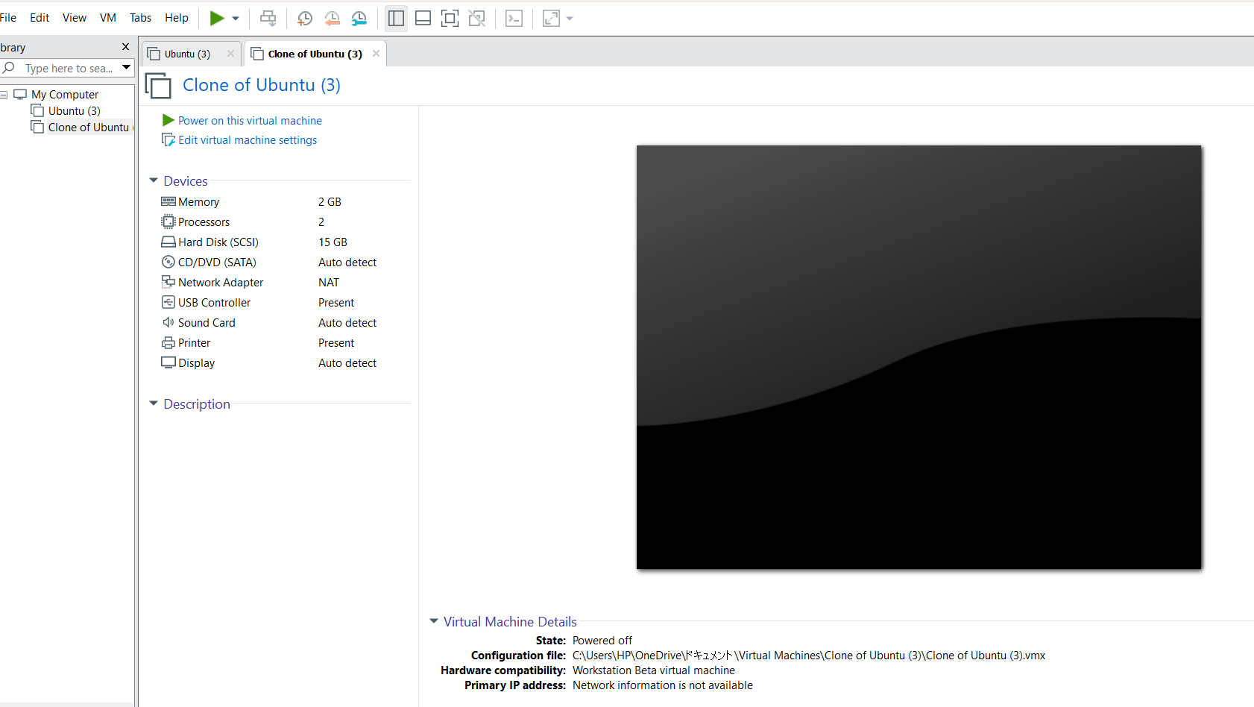
STEP2:
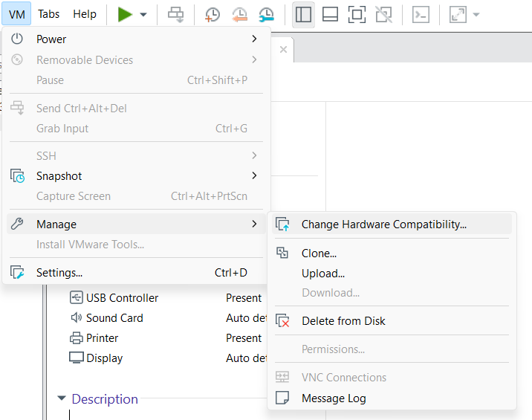
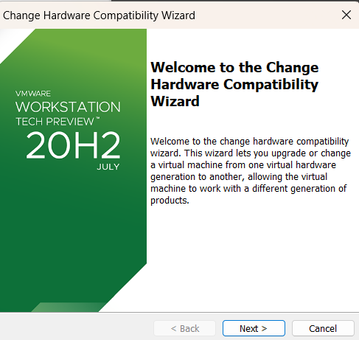

STEP3:
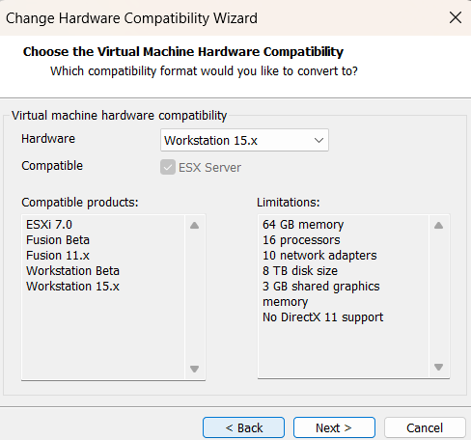

STEP4:
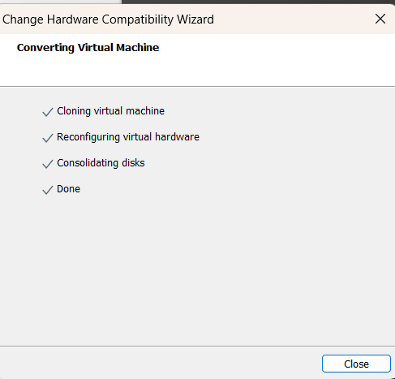

STEP5:
